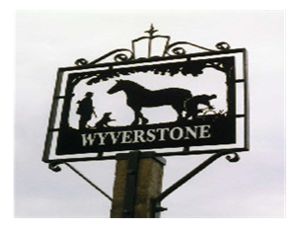

WYVERSTONE PARISH COUNCIL

To members of Wyverstone Parish Council
You are duly summoned to attend the next meeting of Wyverstone Parish Council on Tuesday 8th July 2025 at 7.30 pm in the village hall

Public Participation
At 7.30 pm, before the formal meeting, members of the public are invited to give their views and question the council on issues on this agenda, or to raise issues for future consideration at the discretion of the chairman. The public may not take part in the meeting itself.

AGENDA
- Apologies and approval of absences
- To receive declarations of interests
- To consider requests for dispensations
- To approve as accurate the minutes of the Annual Parish Council meeting held on 13th May 2025
- To receive reports from the district and County councillor
6. Planning matters –

a) to consider the following application:
DC/25/02454 – works to facilitate conversion of barn to holiday let at Grange Farm Barn, Potash Lane, Wyverstone, IP14 4SL

b) decisions or other planning matters to report
(At the Chairman’s discretion, the council will discuss any applications received after the posting of this notice and members of the public can check with the clerk for details prior to the meeting)

7. Financial matters –
a) clerk’s report
b) requests for payment or report of any payments made
c) to review the internal auditor’s report and recommendations following submission of the 2024/5 accounts

8. Correspondence for information

9. Progress reports from resolutions or matters arising from previous meetings

10. AOB

Kate Webster, Clerk to Wyverstone Parish Council,
Mill Farm, Mill Road, Wyverstone 01449 781285

